Lab 07: Fabric IQ, Direct Lake & Semantic Governance

Objective: Build and tune a consolidated enterprise semantic model in Direct Lake mode with Fabric IQ layering, XMLA/TOM version governance, column statistics inspection, and VertiPaq performance optimization.

Case Study: Enterprise Sales Analytics & Semantic Model Optimization

Problem Statement
A large multinational retail organization operates across multiple product categories, customers, and sales regions. Its sales data is continuously generated and stored in an enterprise Gold Lakehouse in Microsoft Fabric.
The organization currently faces several challenges:
- Sales data is stored in large fact tables containing millions of transaction records.
- Different analytics teams create their own calculations and reports, resulting in inconsistent revenue and profitability definitions.
- Business users need a single trusted semantic model for enterprise reporting.
- Analysts require Year-to-Date (YTD) and Year-over-Year (YoY) analysis.
- The existing semantic model contains unnecessary columns and a monolithic fact-table structure.
- Large analytical queries can experience performance degradation.
- The organization needs governance metadata to track model versions, deployment dates, ownership, and changes.
- The data engineering and analytics teams want to use Microsoft Fabric Direct Lake so reports can query OneLake data without maintaining a traditional imported semantic model.

Business Requirement
The organization wants to build a centralized enterprise sales analytics solution in Microsoft Fabric that provides:
- A trusted Direct Lake semantic model over Gold Lakehouse data.
- A proper star schema connecting sales, customer, product, and date dimensions.
- Standardized enterprise measures such as:
  - Total Revenue
  - Total Cost
  - Total Profit
  - Total Quantity
  - Transaction Count
- Reusable time-intelligence calculations:
  - YTD
  - YoY Growth
- A governed semantic model with version and ownership metadata.
- Performance analysis using query execution and storage-level metrics.
- Optimization of unnecessary columns and the underlying Delta table layout.
- A business-facing report that allows management to analyze revenue by Product Category and Calendar Year.

STEP 00: Prerequisites & Environment Setup (Not Counted)
- Target Workspace: Open your assigned Microsoft Fabric workspace with active Fabric capacity enabled.
- Tooling Installation: Ensure local installations of Power BI Desktop (Fabric mode), Tabular Editor 3, and DAX Studio are available on your workstation.
- Permissions & Connectivity: Verify that XMLA Read/Write is enabled at the tenant/capacity level. Copy the Workspace Connection URL via Workspace Settings > Premium > Workspace Connection.
- Instructor-Provided Artifacts: Confirm the instructor-provided Lakehouse containing the consolidated Gold delta tables (Fact_Sales, Dim_Customer, Dim_Date, Dim_Product) is online and accessible.

PHASE 2 — Create the Lakehouse
You are already inside the volkswagen_data workspace.

STEP 0.4 — Create Lakehouse

1. Go to your workspace
You should be on:
volkswagen_data

2. Click
+ New item

3. Search/select
Lakehouse

4. Enter exactly:
Lab07_Gold_Lakehouse

5. Click Create
Wait for Fabric to finish creating it.

STEP 0.5 — Open the Lakehouse
After creation, you should see:
Lab07_Gold_Lakehouse
Click it.
You should see something similar to:
Lab07_Gold_Lakehouse

Explorer
│
├── Tables
│
└── Files
Initially, Tables should be empty.
That's completely fine.
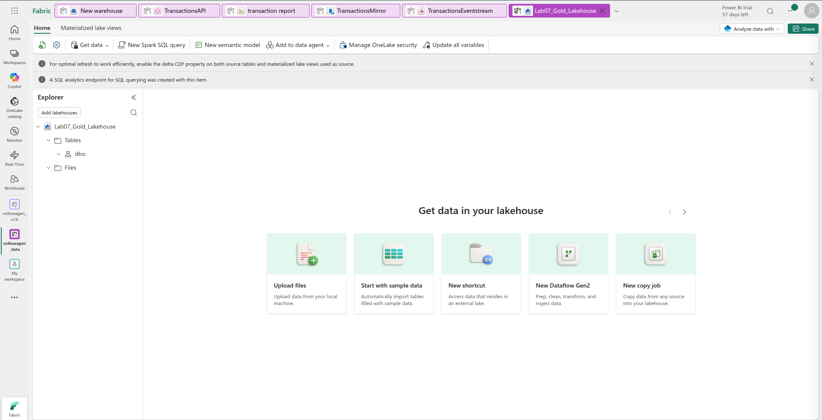

TEP 0.5 — Don't create tables manually
On your current screen, do not click:
- Upload files
- Start with sample data
- New shortcut
- New Dataflow
Instead, create a Notebook from the workspace.

1. Go back to volkswagen_data
Click the volkswagen_data workspace on the left sidebar.

2. Click
+ New item

3. Select
Notebook

4. Name it
Lab07_Data_Generator
Then click Create.

STEP 0.5.1 — Attach your Lakehouse
When the notebook opens, look at the left Explorer pane.
You should find something like:
Add data items
There should be an option:
Add lakehouse
Click it.
Then select:
Lab07_Gold_Lakehouse
and click Add.
After that, the notebook should show:
Lakehouses
└── Lab07_Gold_Lakehouse

1. Create Dim_Customer
In the notebook, create a new code cell and paste:
from pyspark.sql import functions as F

customer_count = 1000

customers = (
spark.range(1, customer_count + 1)
.withColumnRenamed("id", "CustomerKey")

.withColumn(
"CustomerName",
F.concat(
F.lit("Customer "),
F.col("CustomerKey").cast("string")
)
)

.withColumn(
"City",
F.when((F.col("CustomerKey") % 8) == 1, "Pune")
.when((F.col("CustomerKey") % 8) == 2, "Mumbai")
.when((F.col("CustomerKey") % 8) == 3, "Delhi")
.when((F.col("CustomerKey") % 8) == 4, "Bengaluru")
.when((F.col("CustomerKey") % 8) == 5, "Hyderabad")
.when((F.col("CustomerKey") % 8) == 6, "Chennai")
.when((F.col("CustomerKey") % 8) == 7, "Kolkata")
.otherwise("Ahmedabad")
)

.withColumn(
"State",
F.when(
F.col("City").isin("Pune", "Mumbai"),
"Maharashtra"
)
.when(
F.col("City") == "Delhi",
"Delhi"
)
.when(
F.col("City") == "Bengaluru",
"Karnataka"
)
.when(
F.col("City") == "Hyderabad",
"Telangana"
)
.when(
F.col("City") == "Chennai",
"Tamil Nadu"
)
.when(
F.col("City") == "Kolkata",
"West Bengal"
)
.otherwise("Gujarat")
)

.withColumn(
"Segment",
F.when((F.col("CustomerKey") % 3) == 1, "Consumer")
.when((F.col("CustomerKey") % 3) == 2, "Corporate")
.otherwise("Small Business")
)
)

customers.write \
.mode("overwrite") \
.format("delta") \
.saveAsTable("Dim_Customer")

print("Dim_Customer created successfully")
print("Rows:", customers.count())

Run it with Shift + Enter.

Expected
Dim_Customer created successfully
Rows: 1000

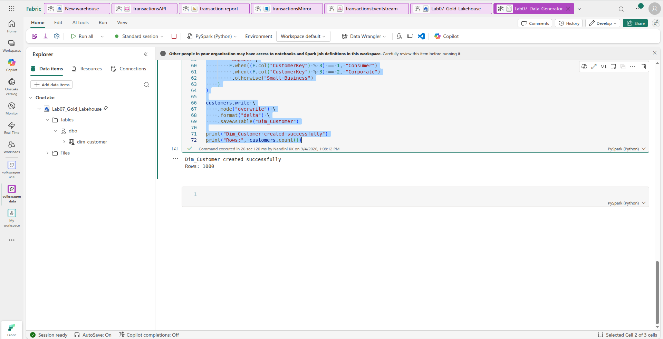

2. Create Dim_Product
Create another cell:
from pyspark.sql import functions as F

# Create 100 products: ProductKey 101-200
products = (
spark.range(101, 201)
.withColumnRenamed("id", "ProductKey")

.withColumn(
"ProductName",
F.concat(
F.lit("Product "),
F.col("ProductKey").cast("string")
)
)

.withColumn(
"ProductCategory",
F.when((F.col("ProductKey") % 3) == 0, "Electronics")
.when((F.col("ProductKey") % 3) == 1, "Furniture")
.otherwise("Office Supplies")
)

.withColumn(
"ProductSubcategory",
F.when(
F.col("ProductCategory") == "Electronics",
F.when(
(F.col("ProductKey") % 2) == 0,
"Computers"
).otherwise("Accessories")
)
.when(
F.col("ProductCategory") == "Furniture",
F.when(
(F.col("ProductKey") % 2) == 0,
"Chairs"
).otherwise("Tables")
)
.otherwise(
F.when(
(F.col("ProductKey") % 2) == 0,
"Stationery"
).otherwise("Paper")
)
)

.withColumn(
"UnitPrice",
F.round(
F.lit(500) +
((F.col("ProductKey") * 137) % 74500),
2
)
)
)

# Write as Delta table
products.write \
.mode("overwrite") \
.format("delta") \
.saveAsTable("Dim_Product")

print("Dim_Product created successfully")
print("Rows:", products.count())

Expected:
Dim_Product created successfully
Rows: 100
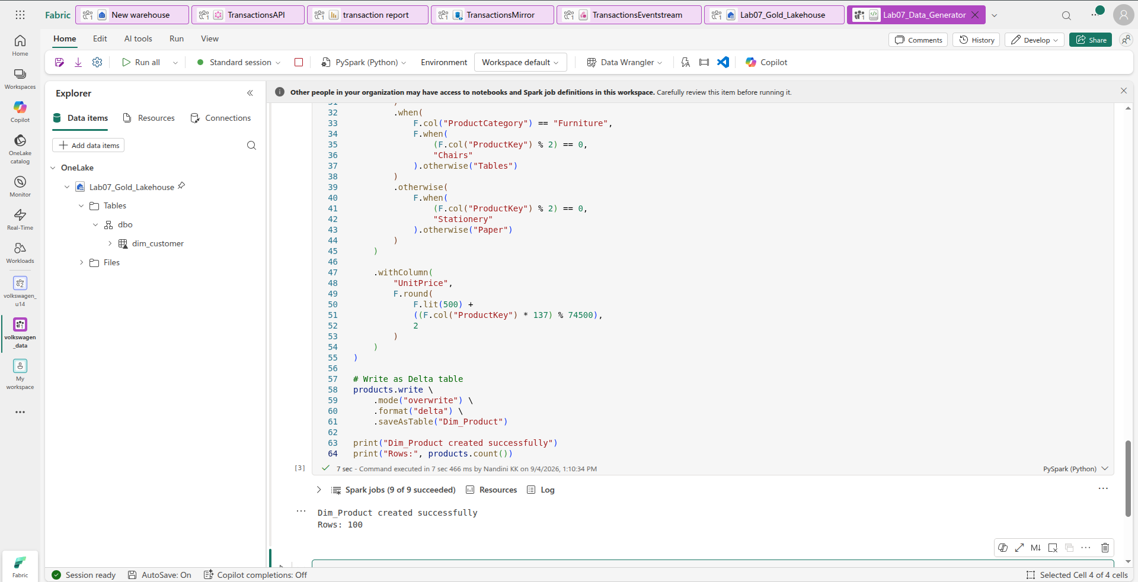

3. Create Dim_Date
New cell:
from pyspark.sql import functions as F

# Create dates from 2025-01-01 to 2026-12-31
dates = (
spark.sql("""
SELECT explode(
sequence(
to_date('2025-01-01'),
to_date('2026-12-31'),
interval 1 day
)
) AS Date
""")
.withColumn(
"DateKey",
F.date_format("Date", "yyyyMMdd").cast("int")
)
.withColumn(
"CalendarYear",
F.year("Date")
)
.withColumn(
"MonthNumber",
F.month("Date")
)
.withColumn(
"MonthName",
F.date_format("Date", "MMMM")
)
.withColumn(
"Quarter",
F.concat(F.lit("Q"), F.quarter("Date"))
)
.select(
"DateKey",
"Date",
"CalendarYear",
"MonthNumber",
"MonthName",
"Quarter"
)
)

# Save as Delta table
dates.write \
.mode("overwrite") \
.format("delta") \
.saveAsTable("Dim_Date")

print("Dim_Date created successfully")
print("Rows:", dates.count())

Run it.
Expected:
Dim_Date created successfully
Rows: 730
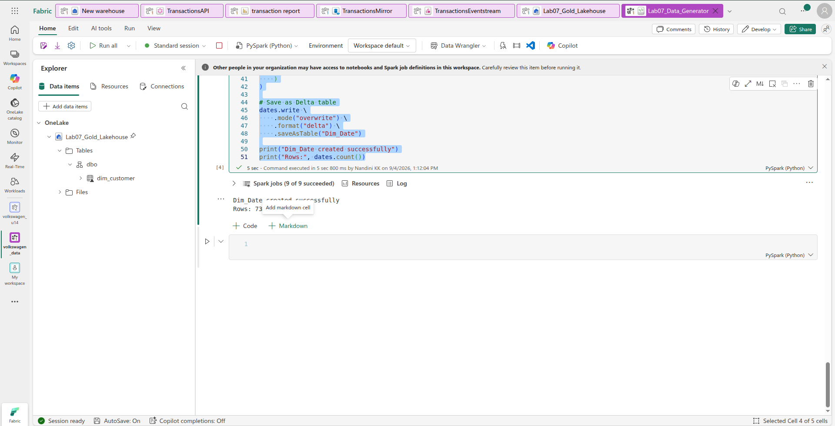

4. Create Fact_Sales
This is the main table and will contain 500,000 rows.
Create a new cell:
from pyspark.sql import functions as F

# Number of sales records
sales_count = 500000

sales = (
spark.range(1, sales_count + 1)
.withColumnRenamed("id", "SalesKey")

# Transaction ID
.withColumn(
"TransactionKey",
(F.lit(1000000) + ((F.col("SalesKey") - 1) / 3).cast("long"))
)

# 1-3 lines per transaction
.withColumn(
"SalesOrderLineNumber",
(((F.col("SalesKey") - 1) % 3) + 1).cast("int")
)

# Date distributed across 2025 and 2026
.withColumn(
"Date",
F.expr(
"date_add("
"to_date('2025-01-01'), "
"cast((SalesKey - 1) % 730 as int)"
")"
)
)

# YYYYMMDD integer key
.withColumn(
"DateKey",
F.date_format("Date", "yyyyMMdd").cast("int")
)

# CustomerKey: 1-1000
.withColumn(
"CustomerKey",
(((F.col("SalesKey") - 1) % 1000) + 1).cast("long")
)

# ProductKey: 101-200
.withColumn(
"ProductKey",
(((F.col("SalesKey") - 1) % 100) + 101).cast("long")
)

# Quantity: 1-10
.withColumn(
"Quantity",
(((F.col("SalesKey") - 1) % 10) + 1).cast("int")
)

# Revenue
.withColumn(
"Revenue",
F.round(
F.col("Quantity") *
(
F.lit(500) +
((F.col("ProductKey") * 137) % 74500)
),
2
)
)

# Cost = 75% of revenue
.withColumn(
"Cost",
F.round(F.col("Revenue") * F.lit(0.75), 2)
)

.select(
"SalesKey",
"TransactionKey",
"SalesOrderLineNumber",
"DateKey",
"CustomerKey",
"ProductKey",
"Quantity",
"Revenue",
"Cost"
)
)

# Write to Lakehouse as Delta
sales.write \
.mode("overwrite") \
.format("delta") \
.saveAsTable("Fact_Sales")

print("Fact_Sales created successfully")
print("Rows:", sales.count())

Expected:
Fact_Sales created successfully
Rows: 500000
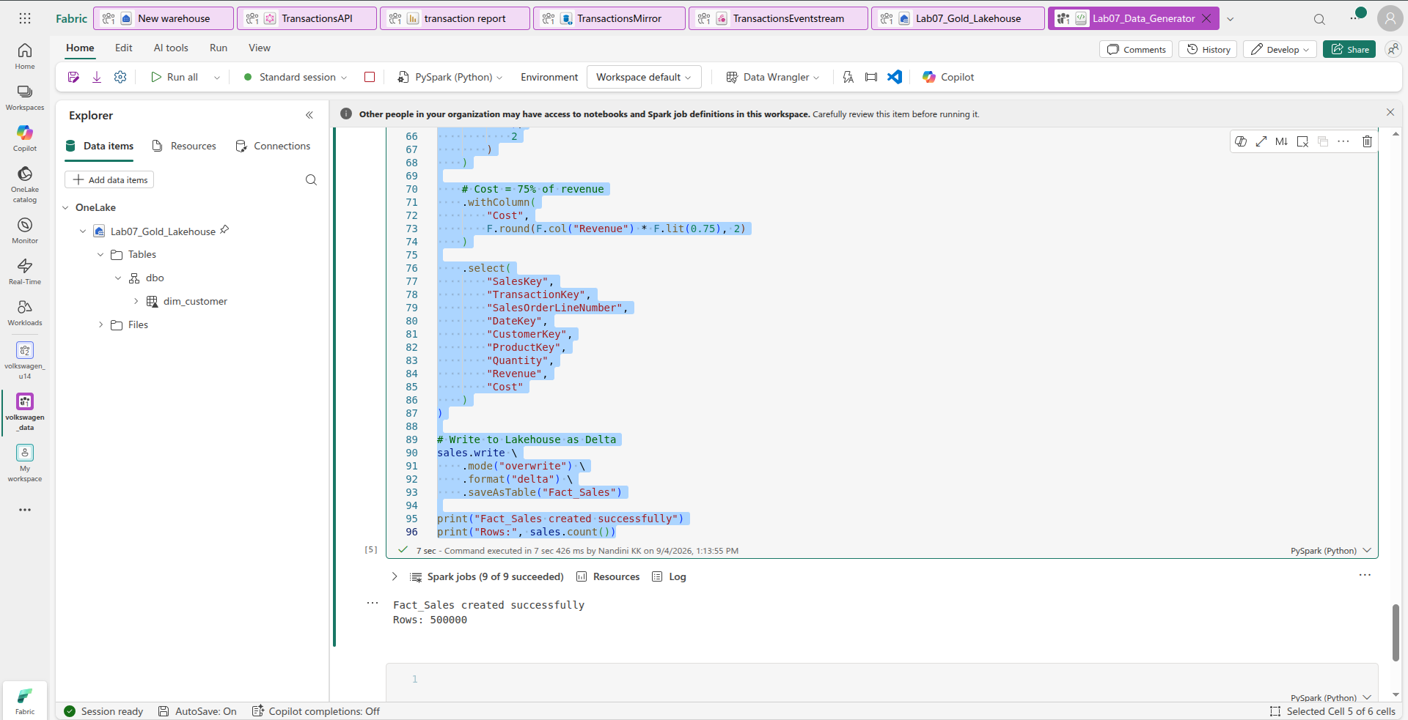

5. Verify all four tables
Finally, create one more cell:
tables = [
"Dim_Customer",
"Dim_Product",
"Dim_Date",
"Fact_Sales"
]

for table in tables:
count = spark.table(table).count()
print(f"{table}: {count:,} rows")
You should get:
Dim_Customer: 1,000 rows
Dim_Product: 100 rows
Dim_Date: 730 rows
Fact_Sales: 500,000 rows
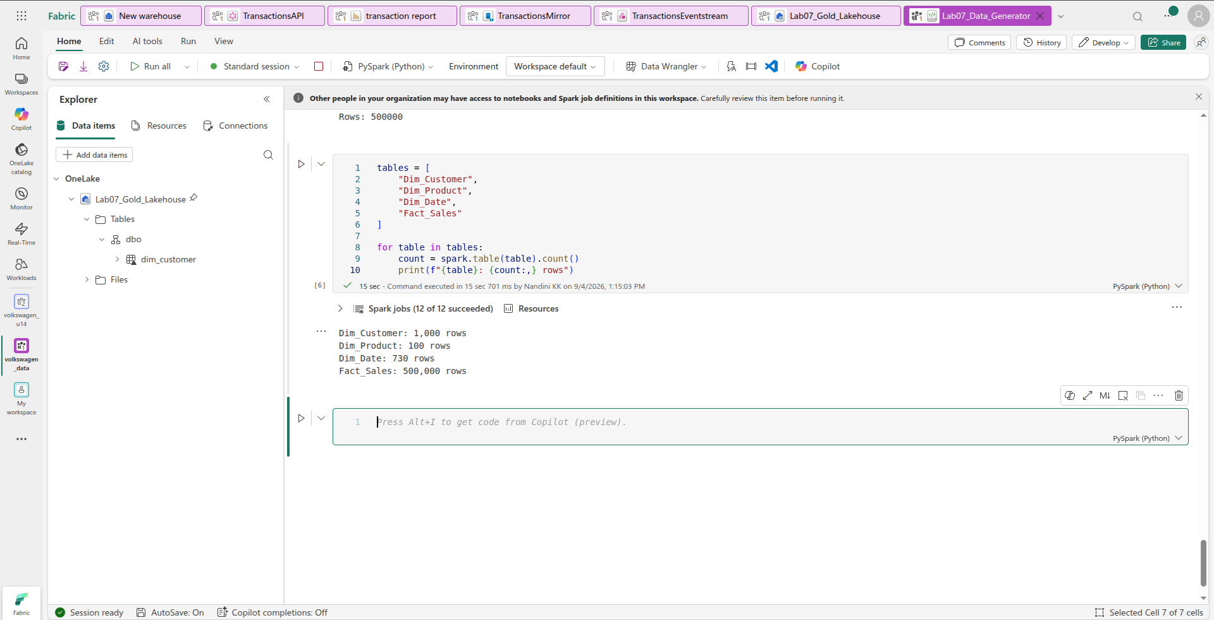

6. Check the Lakehouse
Go back to:
Lab07_Gold_Lakehouse
Refresh the Tables section.
You should now have:
Tables
├── Dim_Customer
├── Dim_Date
├── Dim_Product
└── Fact_Sales

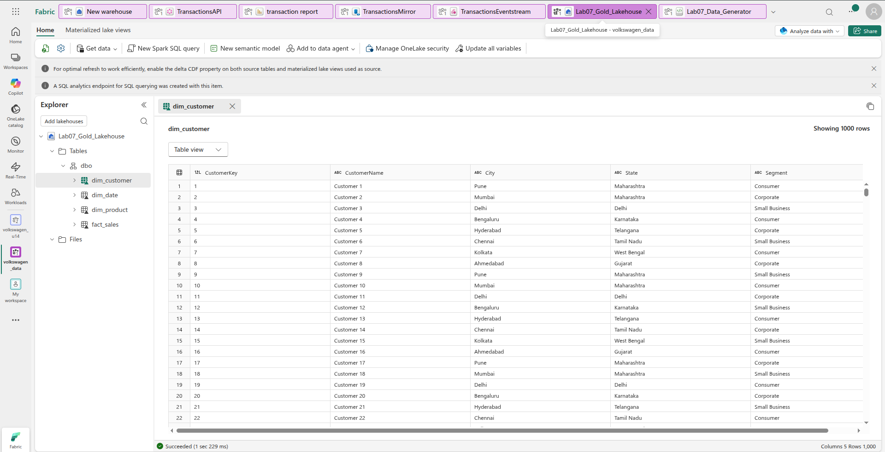

STEP 1 — Create the Direct Lake Semantic Model
The lab requires the consolidated model to contain:
- Fact_Sales
- Dim_Customer
- Dim_Product
- Dim_Date
and ultimately operate in Direct Lake mode.

1. Open your workspace
In Microsoft Fabric, open:
volkswagen_data
Then open:
Lab07_Gold_Lakehouse

2. Click New semantic model
At the top of the Lakehouse page, click:
New semantic model
You should get a screen asking you to select tables.
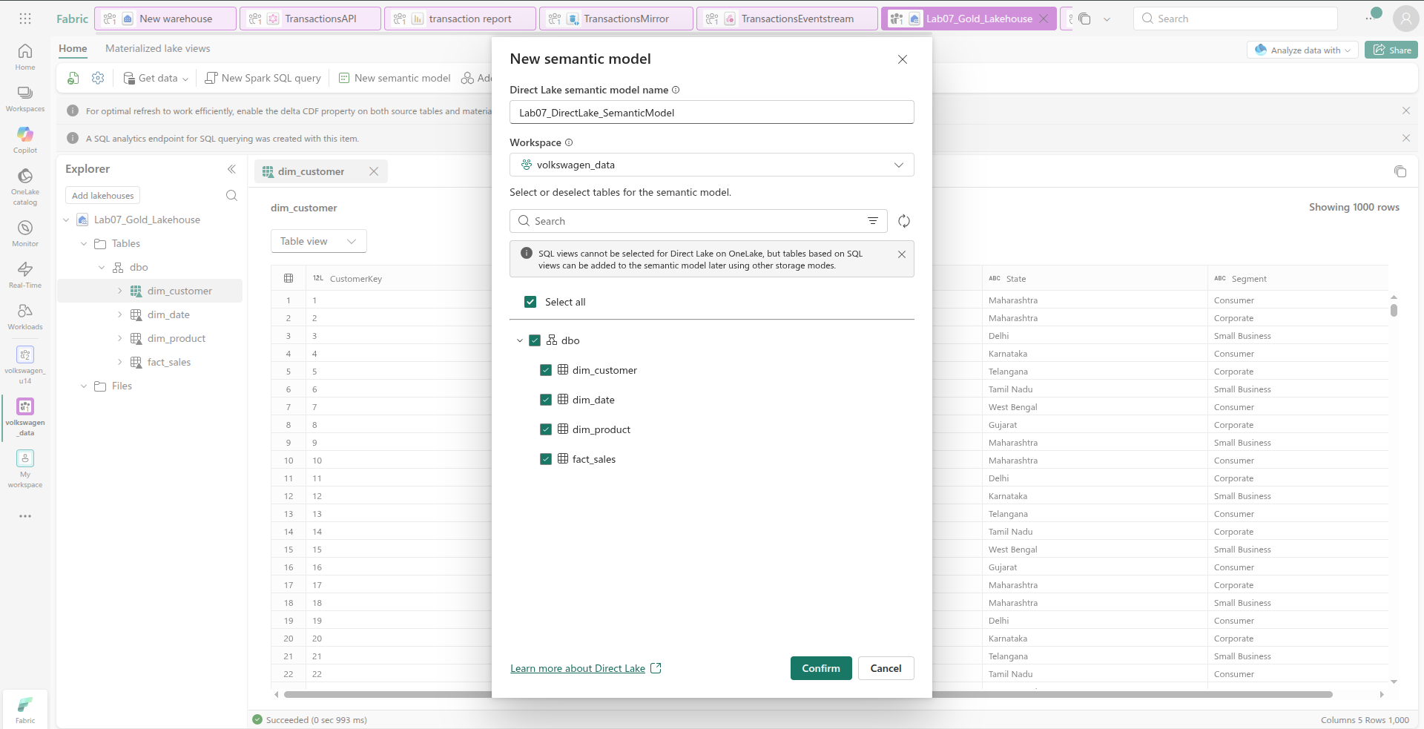

3. Select ONLY these four tables
Tick:
☑ Dim_Customer
☑ Dim_Date
☑ Dim_Product
☑ Fact_Sales
Do not select any of the unrelated tables/assets in your workspace.
The resulting model should represent this star schema:
Dim_Customer
│
│ 1 : *
▼
Dim_Date ────► Fact_Sales ◄──── Dim_Product
1 : * 1 : *
This is consistent with the lab's required modelling fundamentals.
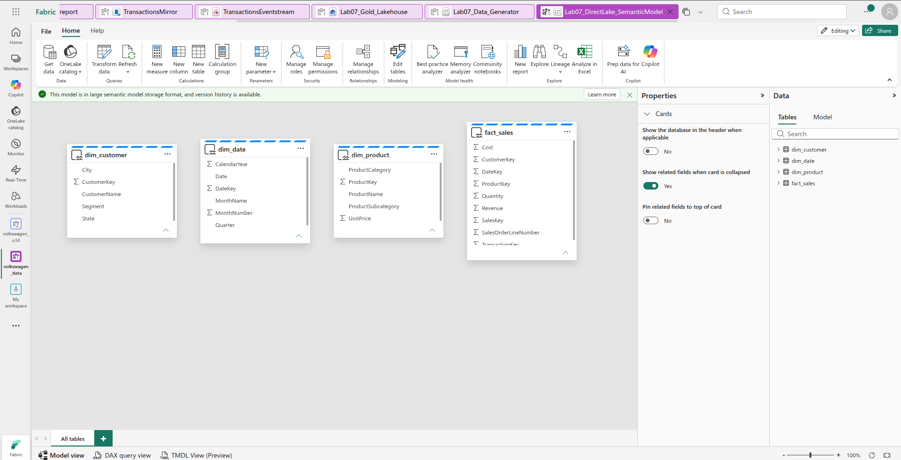

STEP 4 — Create relationships
Click Manage relationships in the top toolbar.
You should get a relationships window.

Relationship 1 — Customer
Click New relationship.
Set:
Setting | Value
From table | dim_customer
From column | CustomerKey
To table | fact_sales
To column | CustomerKey
Cardinality | One to many (1:*)
Cross-filter direction | Single
Make this relationship active | ✅
Then click Save / OK.
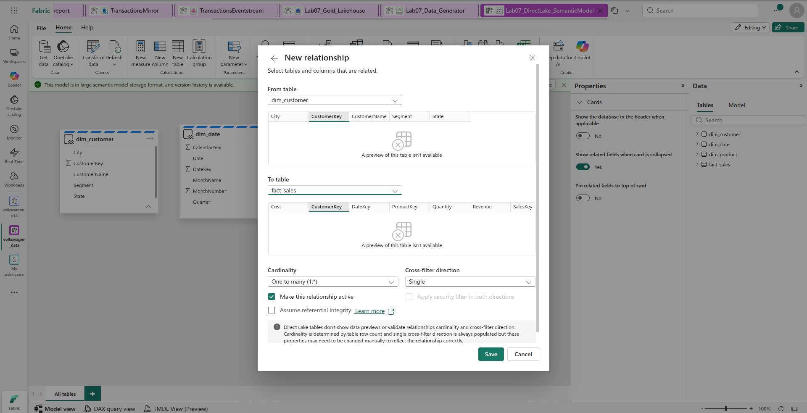

Relationship 2 — Product
Create another relationship:
dim_product[ProductKey]
1
│
│
*
fact_sales[ProductKey]
Settings:
From table: dim_product
From column: ProductKey

To table: fact_sales
To column: ProductKey

Cardinality: One to many (1:*)
Cross-filter: Single
Active: Yes
Save it.

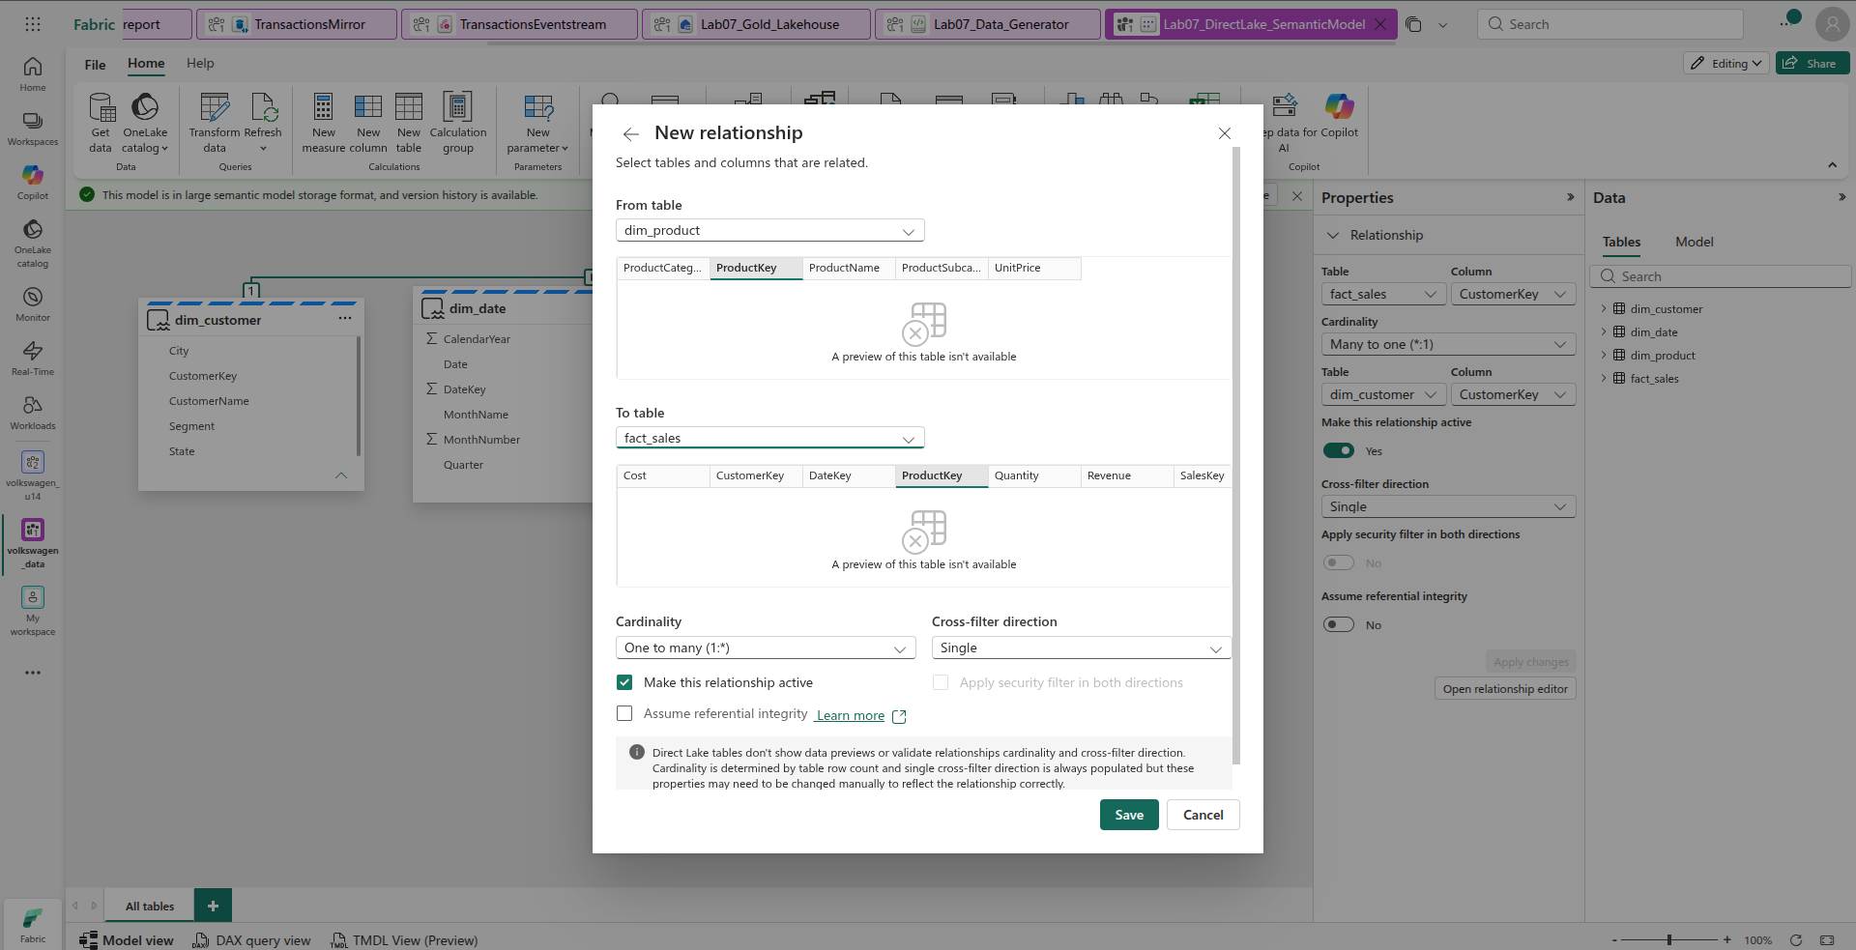

Relationship 3 — Date
Create the third:
dim_date[DateKey]
1
│
│
*
fact_sales[DateKey]
Settings:
From table: dim_date
From column: DateKey

To table: fact_sales
To column: DateKey

Cardinality: One to many (1:*)
Cross-filter: Single
Active: Yes
Save it.
These three relationships give us the required star schema: the dimension tables on the 1-side and fact_sales on the many-side.
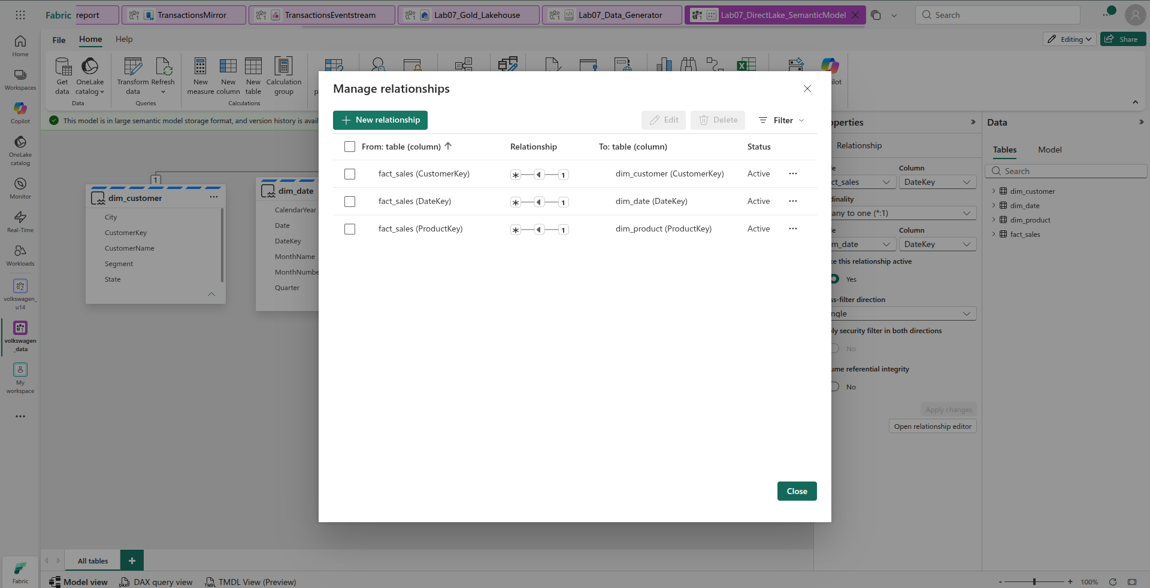

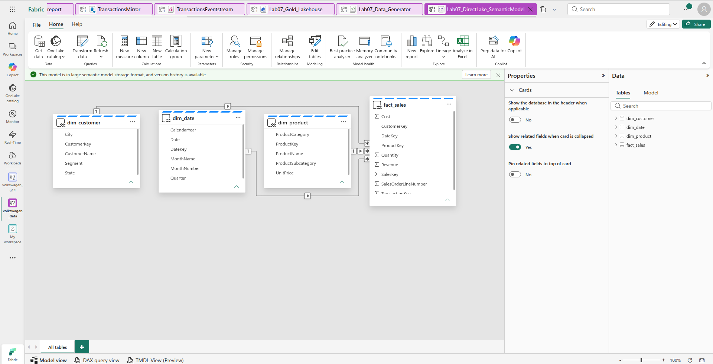

STEP 5 — Create the required DAX measures
The lab requires measures and later uses [Total Revenue] for benchmarking and validation.
You are currently in Model View.

1. Create Total Revenue
At the top toolbar, click:
New measure
Select fact_sales first if Fabric asks which table should contain the measure.
Enter:
Total Revenue = SUM(fact_sales[Revenue])
Press Enter.
Green tick will be seen on top left after complition.
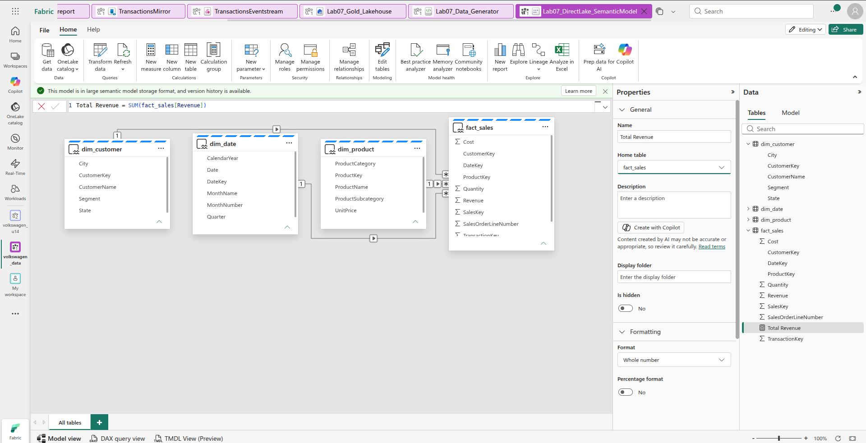

2. Create Total Cost
Click New measure again:
Total Cost = SUM(fact_sales[Cost])
Press Enter.
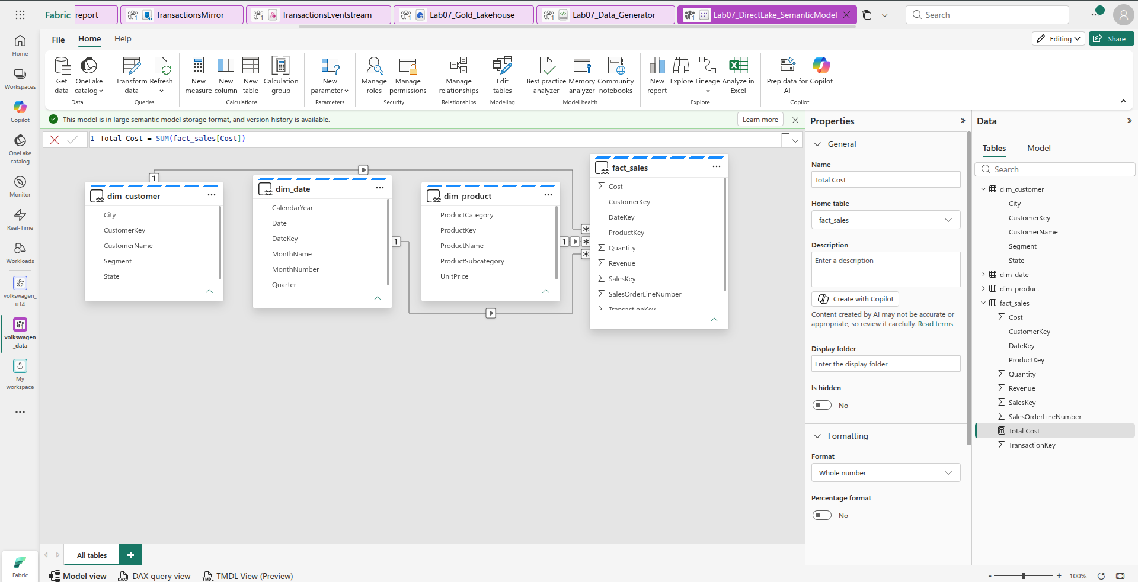

3. Create Total Profit separately
Again:
fact_sales → New measure
Enter only:
Total Profit = [Total Revenue] - [Total Cost]

STEP 6 — Verify the measures
In the right-hand Data pane, expand:
fact_sales
You should eventually see:
Σ Cost
Σ CustomerKey
Σ DateKey
Σ ProductKey
Σ Quantity
Σ Revenue
Σ SalesKey
...

∑ Total Revenue
∑ Total Cost

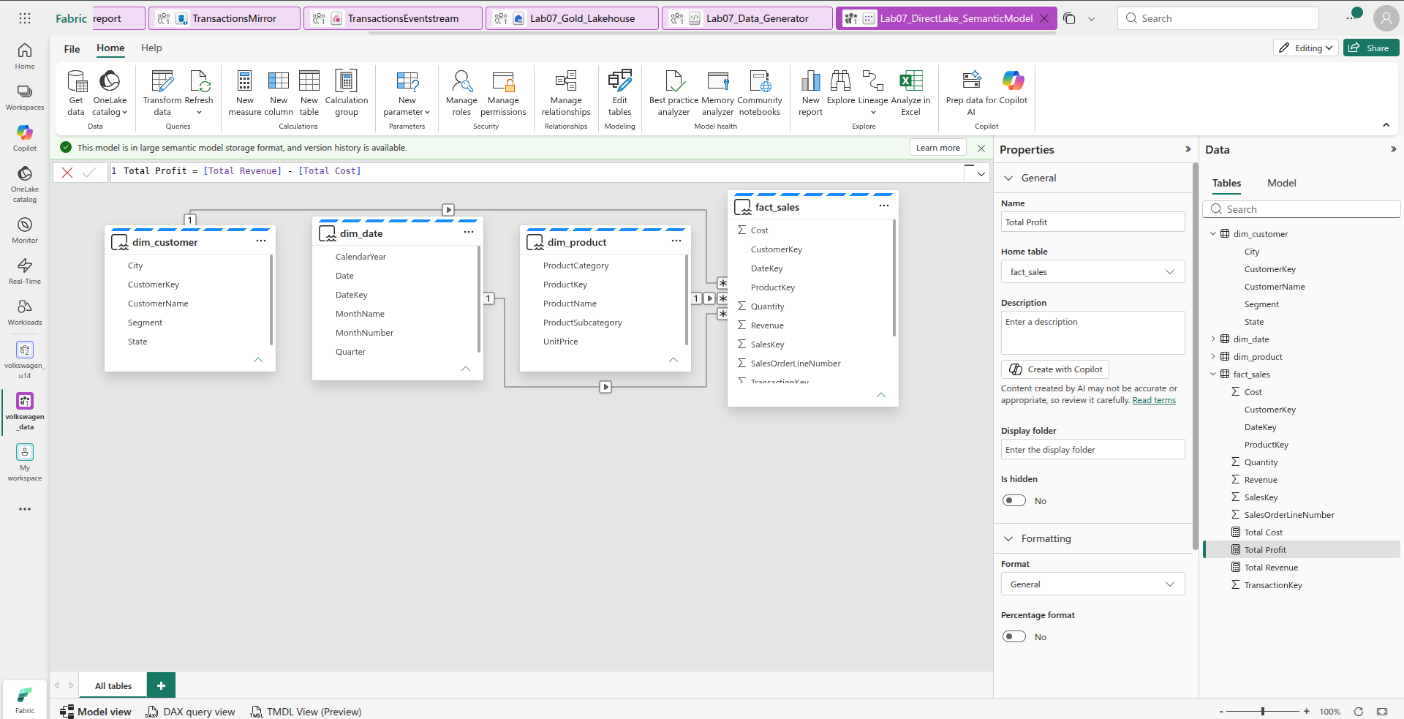
STEP 7 — Create the TimeIntelligence calculation group
This is required by the lab. The lab specifically expects a calculation group named TimeIntelligence with YTD and YoY Growth calculations.

Important
Don't create a normal table called TimeIntelligence.
We need a Calculation Group.

Do this:
At the top toolbar, you have:
New measure | New column | New table | Calculation group
Click:

Calculation group

Yes — this screenshot shows that the Calculation Group has been created successfully. 👍
Right now Fabric has automatically created:
Calculation group
├── Calculation group column
└── Calculation items (1)
└── Calculation item
We now need to rename these and create the two required calculation items.

Step 1 — Rename the Calculation Group
On the right side, under Semantic model → Calculation groups, click:
Calculation group
⚠️ Do not click Calculation item.
Then look at the Properties → Name box.
Change:
Calculation group
to:
TimeIntelligence
Press Enter.

Step 2 — Rename the existing Calculation Item
Under:
Calculation items (1)
click:
Calculation item
The Properties pane should show:
Name: Calculation item
Change the name to:
YTD
Press Enter.

Step 3 — Enter the YTD formula
With YTD selected, click inside the formula bar at the top.
It currently says something like:
Calculation item = SELECTEDMEASURE()
Replace the entire formula with:
CALCULATE(
SELECTEDMEASURE(),
DATESYTD('dim_date'[Date])
)
Then click the ✓ at the left of the formula bar.

Your structure should now look like:
Calculation groups
└── TimeIntelligence
├── Calculation group column
└── Calculation items (1)
└── YTD
The lab requires the TimeIntelligence calculation group with YTD and YoY Growth items.
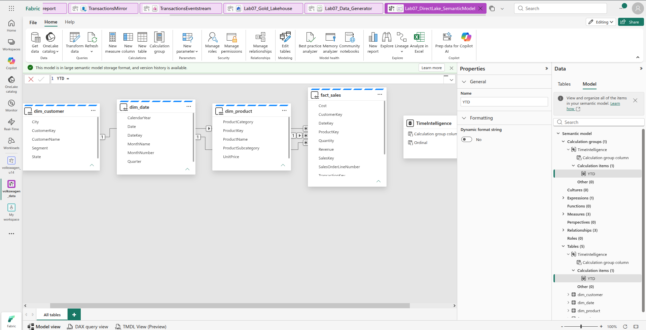
STEP 4 — Create YoY Growth

1. Select TimeIntelligence
On the right Model pane, expand:
Semantic model
└── Calculation groups
└── TimeIntelligence
Then find:
Calculation items (1)
└── YTD

2. Create another calculation item
Right-click Calculation items under TimeIntelligence.
Choose:
New calculation item
Fabric should create another item, probably named:
Calculation item 2

3. Rename it
Select the new calculation item.
In Properties → Name, change it to:
YoY Growth

4. Enter the YoY formula
With YoY Growth selected, replace the formula at the top with:
VAR CurrentValue =
SELECTEDMEASURE()

VAR PreviousYearValue =
CALCULATE(
SELECTEDMEASURE(),
SAMEPERIODLASTYEAR('dim_date'[Date])
)

RETURN
DIVIDE(
CurrentValue - PreviousYearValue,
PreviousYearValue
)
Then click the ✓ at the top-left.

5. Verify
Your model should now show:
Calculation groups
└── TimeIntelligence
├── Calculation group column
└── Calculation items (2)
├── YTD
└── YoY Growth
This matches the lab's requirement for a TimeIntelligence calculation group containing YTD and YoY Growth items.

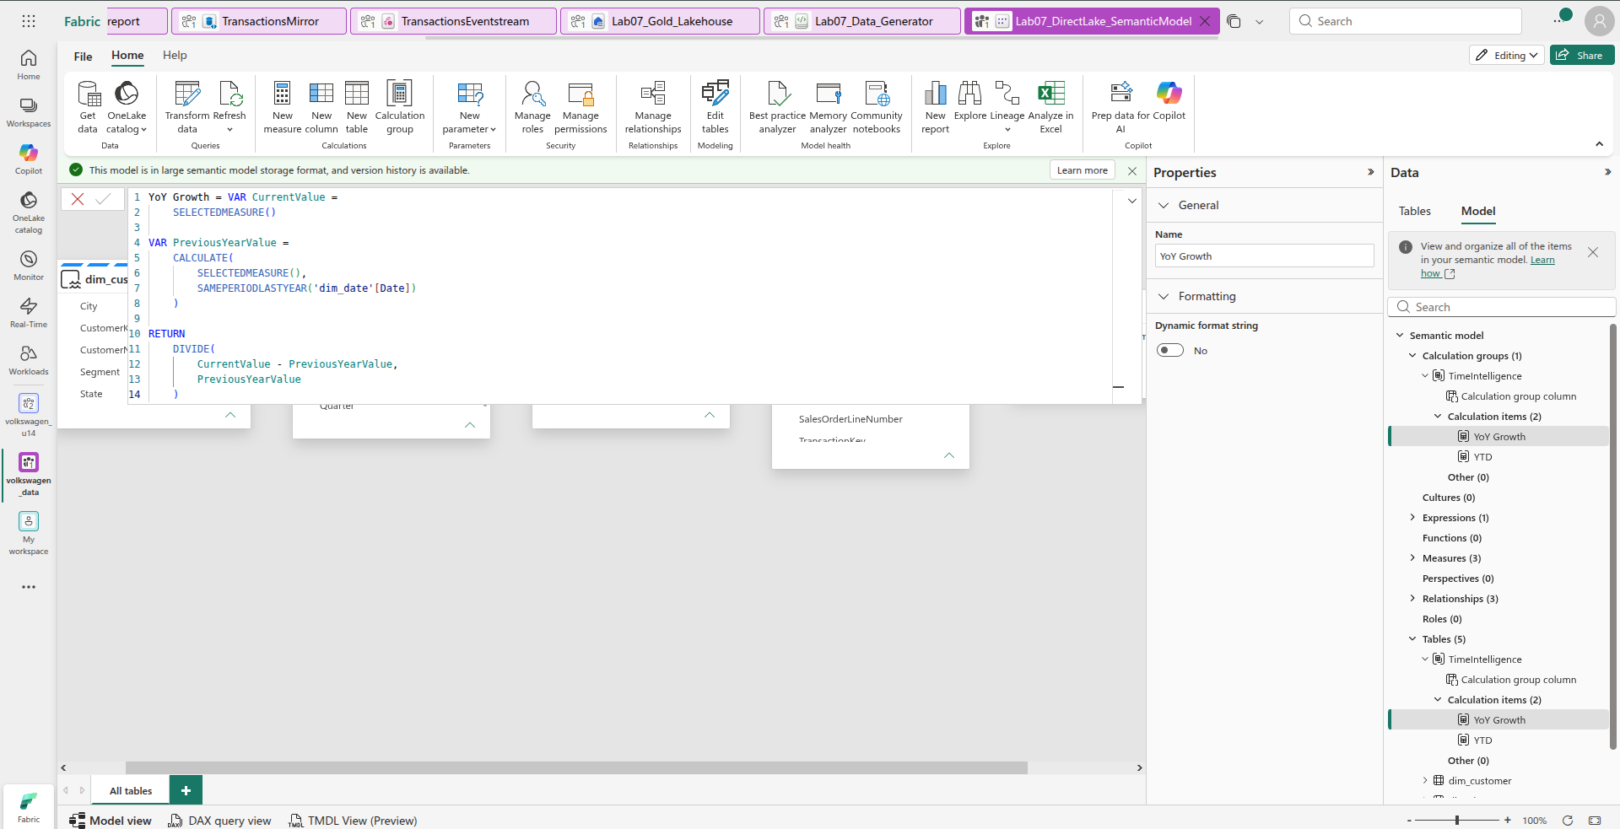
STEP 05 — Create the display folders
We will organize the measures like this:
fact_sales
│
├── Finance Metrics
│ ├── Total Revenue
│ ├── Total Cost
│ └── Total Profit
│
└── Sales Operations
├── Total Quantity
└── Transaction Count

Part A — Put the existing 3 measures into Finance Metrics

1. Select Total Revenue
In the right Data → Tables pane:
fact_sales → Total Revenue
Click Total Revenue.

2. Find Properties
On the middle/right Properties panel, look for:
Display folder
It should currently be empty.
Enter:
Finance Metrics
Press Enter.

3. Do the same for Total Cost
Select:
fact_sales → Total Cost
Set:
Display folder = Finance Metrics

4. Do the same for Total Profit
Select:
fact_sales → Total Profit
Set:
Display folder = Finance Metrics

Part B — Create Sales Operations measures
We currently don't have an operational measure, so we'll create two.

5. Create Total Quantity
Click New measure.
Enter only this:
Total Quantity = SUM(fact_sales[Quantity])
Click ✓.
Then select the new Total Quantity measure.
In Properties → Display folder, enter:
Sales Operations

6. Create Transaction Count
Click New measure again.
Enter:
Transaction Count = DISTINCTCOUNT(fact_sales[TransactionKey])
Click ✓.
Set its:
Display folder = Sales Operations

Part C — Verify
In the model pane, fact_sales should now contain the two folders:

where to go in properties
Yes, you're exactly at the right place. 👍
In your screenshot, the second calculation item is selected. On the right under Properties → General, you can see:
Name
[ Calculation item ]

Step 1 — Rename it
Click the Name box on the right.
Currently:
Calculation item
Change it to:
YoY Growth
Press Enter.

Step 2 — Enter the formula
Now look at the formula bar at the very top. It currently says:
Calculation item = SELECTEDMEASURE()
Select everything in the formula bar and replace it with:
CALCULATE(
SELECTEDMEASURE(),
SAMEPERIODLASTYEAR('dim_date'[Date])
)
Then click the ✓ green checkmark at the top-left.

⚠️ One correction
The formula above calculates previous-year value, but the lab calls the item YoY Growth. To actually calculate growth percentage, use this instead:
VAR CurrentValue =
SELECTEDMEASURE()

VAR PreviousYearValue =
CALCULATE(
SELECTEDMEASURE(),
SAMEPERIODLASTYEAR('dim_date'[Date])
)

RETURN
DIVIDE(
CurrentValue - PreviousYearValue,
PreviousYearValue
)
Use this second formula for YoY Growth.
After saving, your right panel should show:
TimeIntelligence
└── Calculation items (2)
├── Calculation item ← rename this to YoY Growth
└── YTD
So first rename Calculation item → YoY Growth, then enter the formula above.
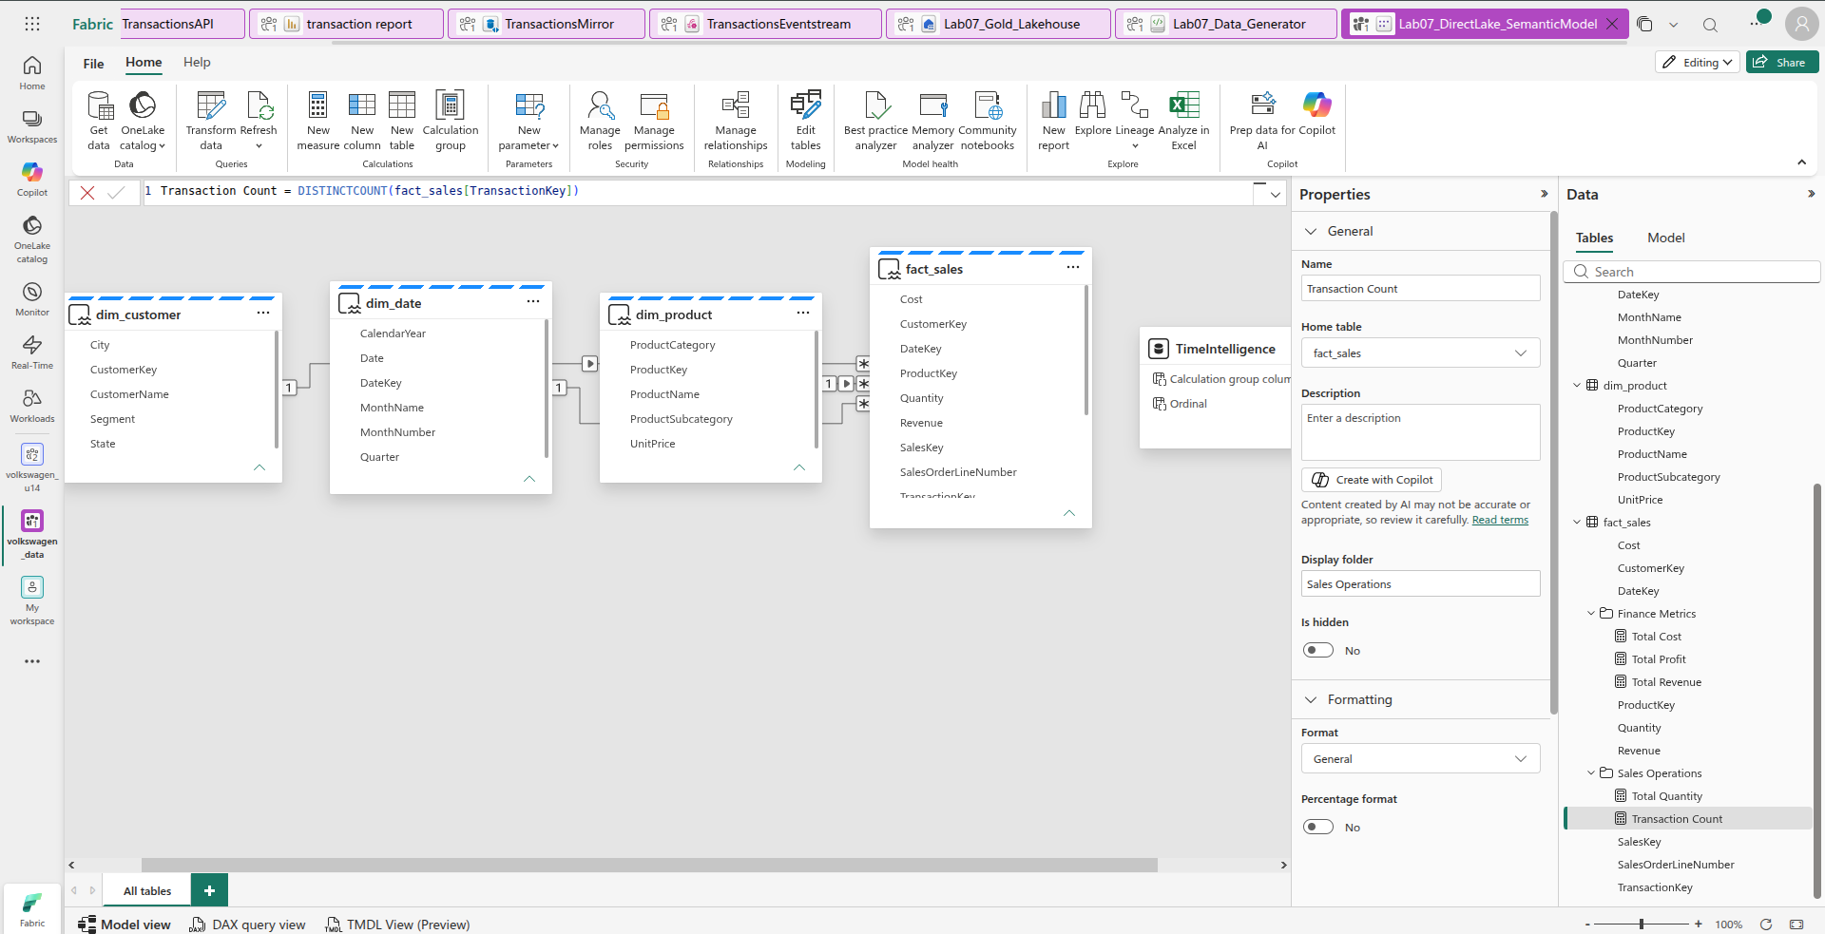

STEP 07 — Validate Direct Lake Partition Using TMDL View
Objective:
Validate the Direct Lake configuration of the fact_sales table in the Lab07_DirectLake_SemanticModel.

Procedure
- Opened the Lab07_DirectLake_SemanticModel in the Microsoft Fabric workspace volkswagen_data.
- Opened TMDL View (Preview) from the bottom navigation of the semantic model.
- In the Data pane on the right, expanded the fact_sales table.
- Dragged the fact_sales table into the TMDL editor to generate its semantic-model metadata definition.
- Used Ctrl + F in the TMDL editor and searched for:
partition
- Navigated to the fact_sales partition definition and verified the following configuration:
partition fact_sales = entity
mode: directLake
source
entityName: fact_sales
schemaName: dbo
expressionSource: 'DirectLake - Lab07_Gold_Lakehouse'

Validation Results
The TMDL metadata confirmed that:
- The fact_sales table exists in the semantic model. ✅
- A partition named fact_sales exists. ✅
- The partition mode is Direct Lake. ✅
- The source entity is fact_sales. ✅
- The schema is dbo. ✅
- The source is the Lab07_Gold_Lakehouse through the Direct Lake expression. ✅
- The TMDL editor showed Problems: 0. ✅

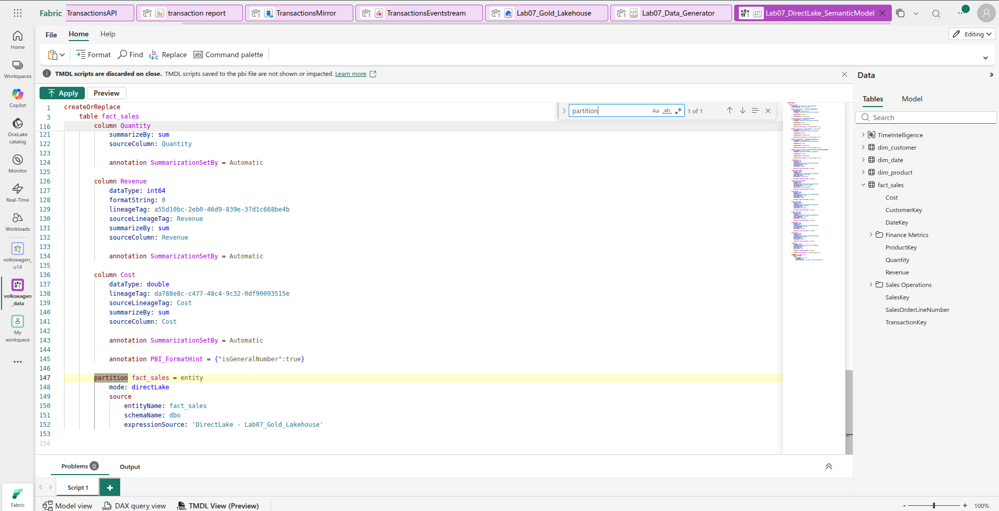
STEP 08 — Establish Semantic-Model Version Governance

Step 1 — Opened the semantic model
We were working in:
Lab07_DirectLake_SemanticModel
inside the volkswagen_data workspace.

Step 2 — Opened TMDL View
At the bottom of the semantic model, we selected:
TMDL View (Preview)

Step 3 — Opened the Model pane
On the right side, we selected:
Model
This showed:
- Semantic model
- Calculation groups
- Measures
- Relationships
- Tables

Step 4 — Scripted the model TMDL
We clicked the ... next to Semantic model.
Then:
Script TMDL to → Script tab
This generated the complete semantic-model TMDL.
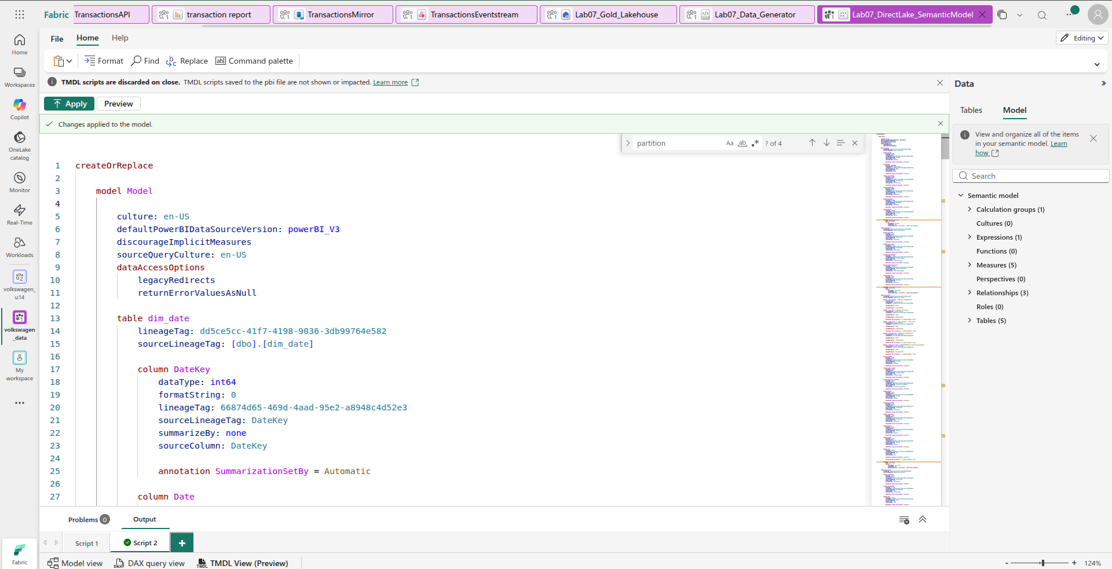
STEP 09 — Capture DAX Performance Baseline
The lab asks us to use DAX Studio and capture performance information for a representative query.
Because you are using Fabric Web DAX Query View, we performed the equivalent validation there.

Step 1 — Open the semantic model
Opened:
Lab07_DirectLake_SemanticModel
in the Fabric workspace.

Step 2 — Open DAX Query View
At the bottom of the semantic model, clicked:
DAX query view

Step 3 — Initially ran the benchmark query
We first used a query containing:
EVALUATE
SUMMARIZECOLUMNS(
'dim_date'[CalendarYear],
'dim_product'[ProductCategory],
"Total Revenue", [Total Revenue]
)

Step 6 — Clicked Run
The query successfully executed.
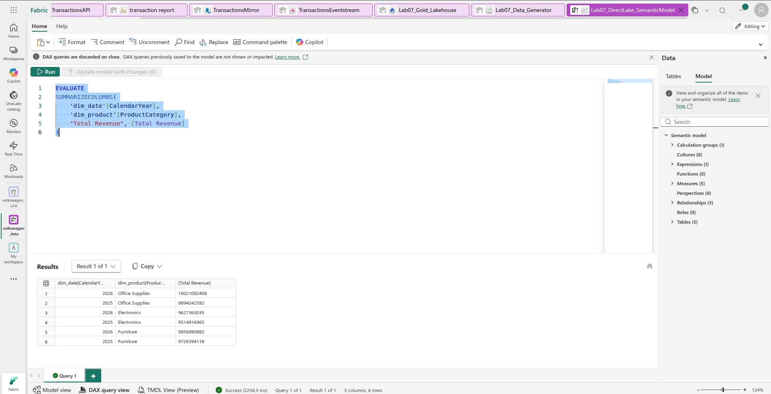
STEP 11 — Inspect Partition Layout
This is what we'll do next.

1. At the bottom of your screen
Click:
TMDL View (Preview)

2. Click the Tables tab on the right
You should see:
- TimeIntelligence
- dim_customer
- dim_date
- dim_product
- fact_sales

3. Expand fact_sales

4. Drag fact_sales into the TMDL editor

5. Press:
Ctrl + F

6. Search:
partition fact_sales
You should find:
partition fact_sales = entity
mode: directLake
source
entityName: fact_sales
schemaName: dbo
expressionSource: 'DirectLake - Lab07_Gold_Lakehouse'
This will confirm the current partition layout.
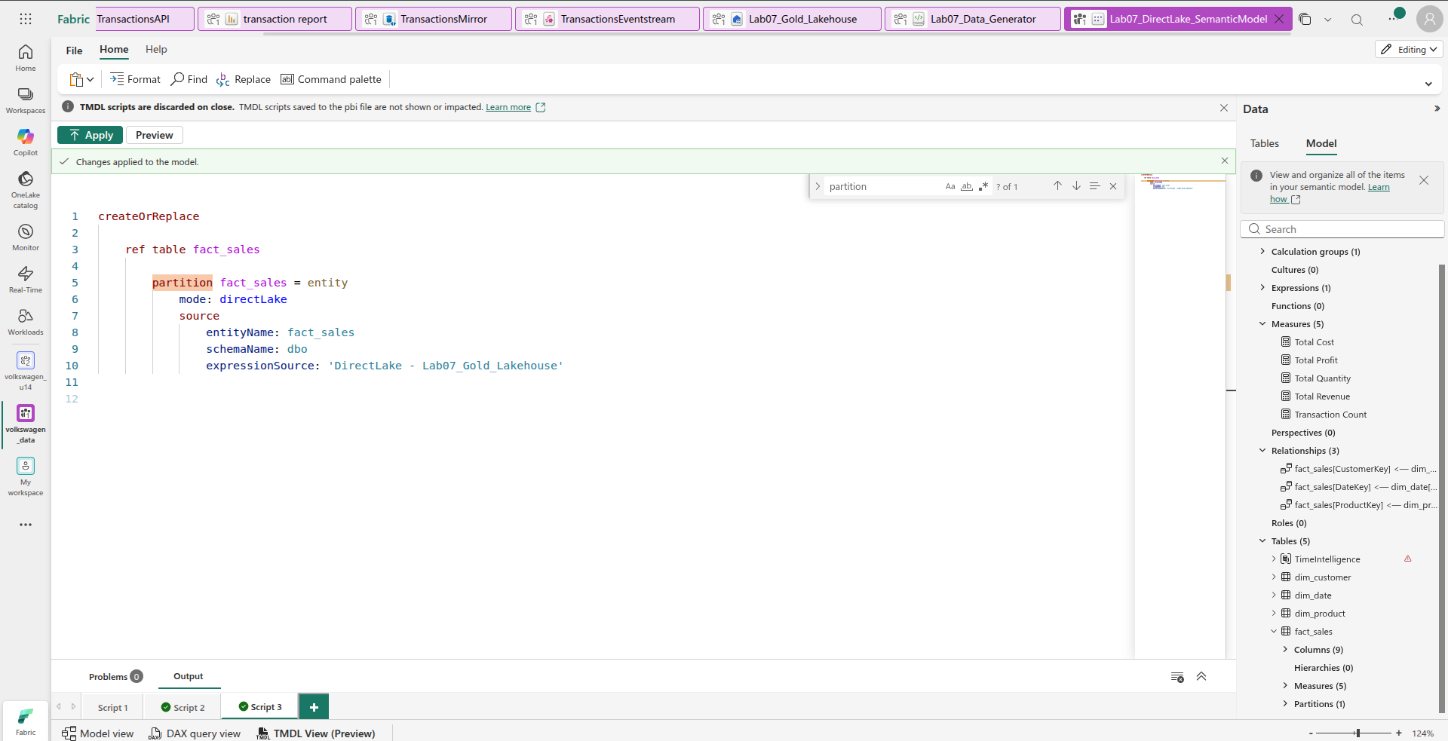

STEP 12 — Apply Direct Lake Performance Optimization
According to your lab, Step 12 has 3 required actions:

1. Hide SalesOrderLineNumber
In Fact_Sales, hide:
Fact_Sales[SalesOrderLineNumber]
The reason is that this is a redundant line-item field that isn't needed for user analysis.

2. Split the Fact_Sales partition
Currently your model has:
Fact_Sales
└── Partitions (1)
└── fact_sales
So it has one monolithic partition.
Step 12 requires changing this to annual partitions:
Fact_Sales
├── Fact_Sales_2025
└── Fact_Sales_2026
These should correspond to the Delta/Parquet directories for the two years.
Step 12A — hide the column
- Stay in your current TMDL View.
- In the right Model pane, expand:
fact_sales → Columns (9)
- Find:
SalesOrderLineNumber
- Right-click SalesOrderLineNumber.
- Choose Script TMDL to new tab.

Step 12B — do this next
Add a new notebook cell below the failed cell and paste:
from pyspark.sql.functions import col

# Load the existing Fact_Sales table
fact_sales_existing = spark.table("Fact_Sales")

# Check the existing data
print("Rows:", fact_sales_existing.count())
print("Columns:", fact_sales_existing.columns)

Then run this cell
Click the Run ▶ button for that cell.

Expected result
You should see something like:
Rows: 500000
Columns: ['SalesKey', 'TransactionKey', 'SalesOrderLineNumber',
'DateKey', 'CustomerKey', 'ProductKey',
'Quantity', 'Revenue', 'Cost']
Notebook — Step 12.1: Load existing Fact_Sales
New cell:
from pyspark.sql.functions import year, to_date, col

# Load the existing Fact_Sales table
fact_sales_existing = spark.table("Fact_Sales")

# Verify existing data
print("Rows:", fact_sales_existing.count())
print("Columns:", fact_sales_existing.columns)

Expected output
Rows: 500000
Columns: ['SalesKey', 'TransactionKey', 'SalesOrderLineNumber',
'DateKey', 'CustomerKey', 'ProductKey',
'Quantity', 'Revenue', 'Cost']

Step 12.2: Create the year column
New cell:
# Convert DateKey (YYYYMMDD integer) into a date
# and extract the year for partitioning

fact_sales_partitioned = fact_sales_existing.withColumn(
"SalesYear",
year(
to_date(
col("DateKey").cast("string"),
"yyyyMMdd"
)
)
)

# Verify year distribution
fact_sales_partitioned.groupBy("SalesYear") \
.count() \
.orderBy("SalesYear") \
.show()

Expected output
+---------+------+
|SalesYear| count|
+---------+------+
|2025 |250025|
|2026 |249975|
+---------+------+

Step 12.3: Create the physically partitioned Delta table
New cell:
# Create a physically partitioned Delta table
# without modifying the original Fact_Sales table

fact_sales_partitioned.write \
.format("delta") \
.mode("overwrite") \
.partitionBy("SalesYear") \
.saveAsTable("Fact_Sales_YearPartitioned")

print("Fact_Sales_YearPartitioned created successfully.")

Expected output
Fact_Sales_YearPartitioned created successfully.

Step 12.4: Verify Delta partitioning
New cell:
spark.sql("""
DESCRIBE DETAIL Fact_Sales_YearPartitioned
""").select(
"name",
"format",
"partitionColumns",
"numFiles"
).show(truncate=False)

Your actual result
format delta
partitionColumns [SalesYear]
numFiles 2
✅ This confirms physical Delta partitioning.

Step 12.5: Verify the annual partitions
New cell:
spark.sql("""
SELECT
SalesYear,
COUNT(*) AS RowCount
FROM Fact_Sales_YearPartitioned
GROUP BY SalesYear
ORDER BY SalesYear
""").show()

Your actual result
+---------+--------+
|SalesYear|RowCount|
+---------+--------+
|2025 |250025 |
|2026 |249975 |
+---------+--------+

Step 12.6: Verify no rows were lost
New cell:
print(
"Original Fact_Sales:",
spark.table("Fact_Sales").count()
)

print(
"Partitioned Fact_Sales:",
spark.table("Fact_Sales_YearPartitioned").count()
)

Your actual result
Original Fact_Sales: 500000
Partitioned Fact_Sales: 500000
✅ Data integrity confirmed.

Step 12.7: Hide SalesOrderLineNumber
This part was not done in the notebook. You did it in the Fabric semantic model TMDL View.
The final successful TMDL was:
createOrReplace

ref table fact_sales

column SalesOrderLineNumber
isHidden
dataType: int64
formatString: 0
lineageTag: 30881b30-4c27-4e79-8ca8-a4ad76e4a418
sourceLineageTag: SalesOrderLineNumber
summarizeBy: sum
sourceColumn: SalesOrderLineNumber
annotation SummarizationSetBy = Automatic
Your screenshot showed:
Changes applied to the model.
Problems: 0
✅ SalesOrderLineNumber successfully hidden.
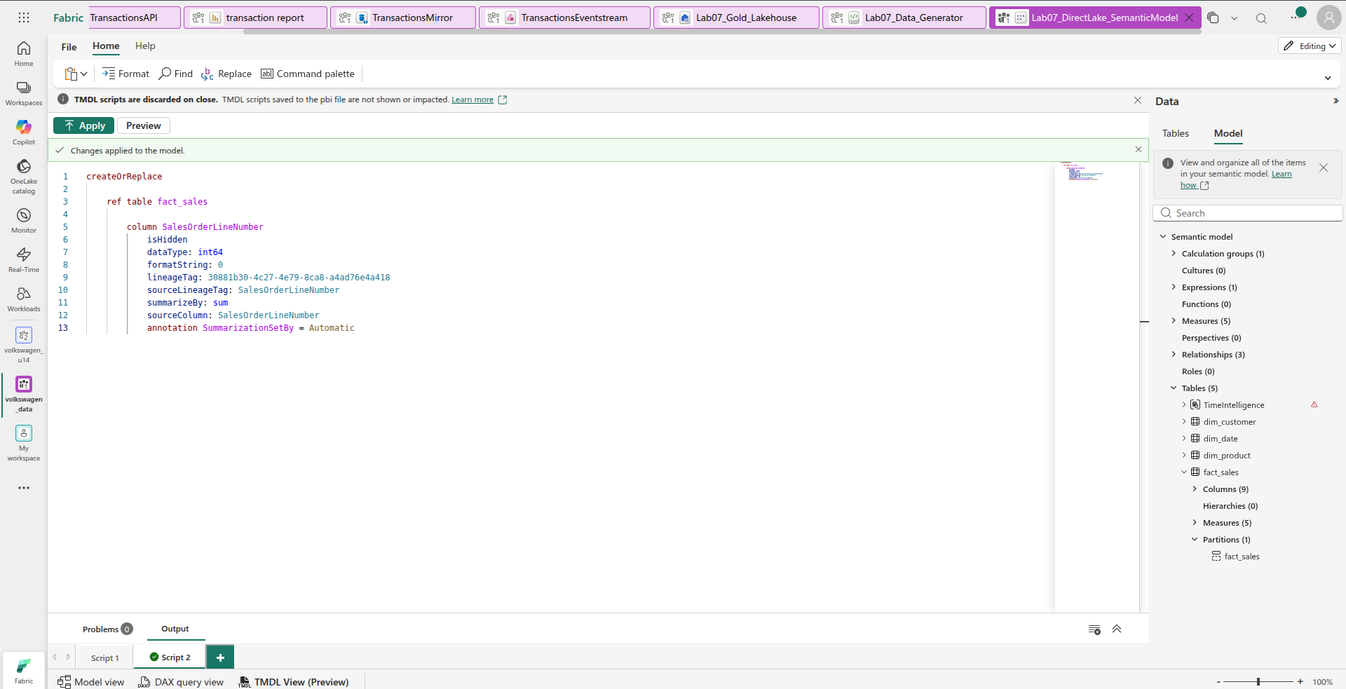
STEP 13 — Re-run Workload and Compare Performance Metrics.

1. Click your semantic model tab
Lab07_DirectLake_SemanticModel

2. At the bottom click
DAX query view

3. Run this exact same benchmark query you used in Step 09:
EVALUATE
SUMMARIZECOLUMNS(
'dim_date'[CalendarYear],
'dim_product'[ProductCategory],
"Total Revenue", [Total Revenue]
)

4. Run it
Wait for the query to finish.

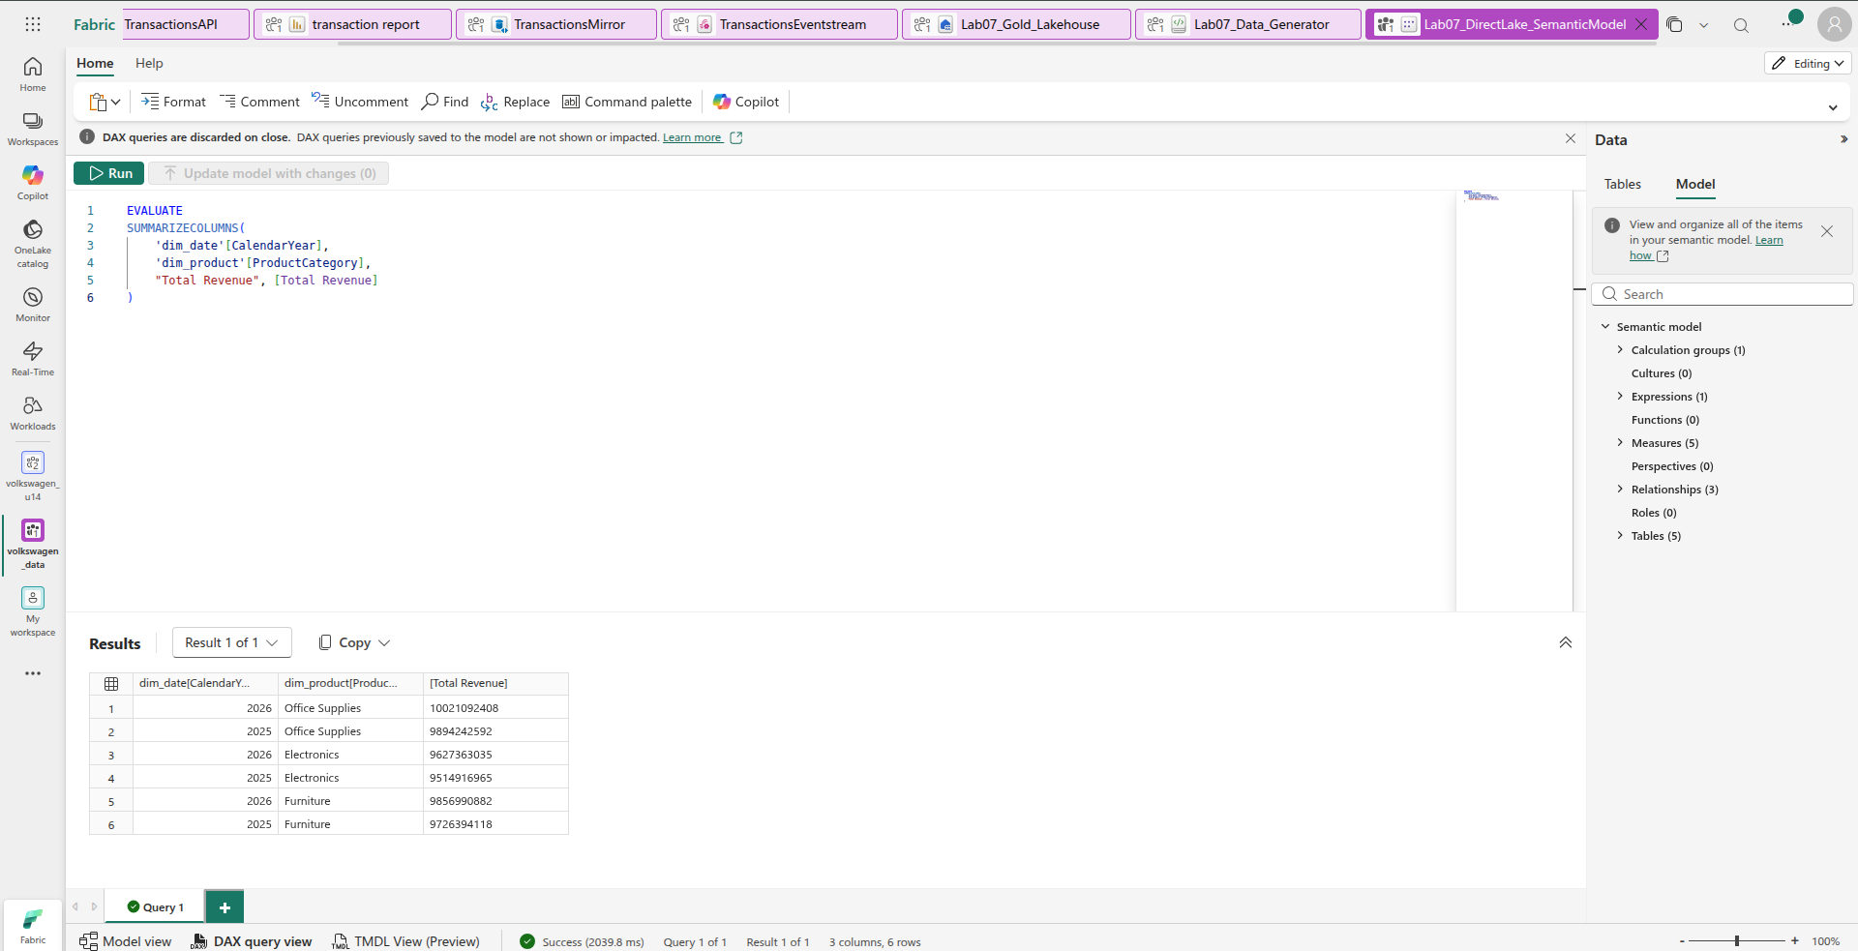
STEP 14 — Validate Consolidated Model Integrity

Step 14.1 — Open the semantic model
You are already in:
Lab07_DirectLake_SemanticModel
At the bottom, click:
Model view
You should see your model with:
- dim_customer
- dim_date
- dim_product
- fact_sales
- TimeIntelligence

Step 14.2 — Open the reporting/exploration view
From the semantic model, open the option to Explore this data / Create a report (wording can vary in Fabric).
We need a temporary table visual.
Add these fields:
Rows/columns:
- dim_product[ProductCategory]
- dim_date[CalendarYear]
Value:
- [Total Revenue]
Your resulting table should contain combinations similar to:
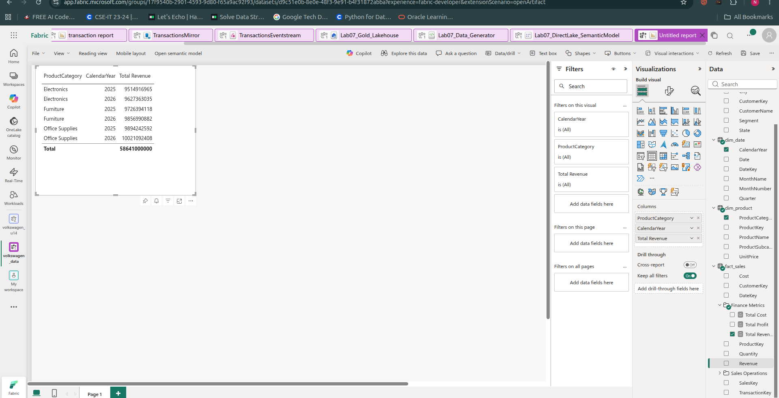

Step 14.3 — Test the calculation group
Now test the TimeIntelligence calculation group.
Use:
TimeIntelligence → calculation group column
and test:
- YTD
- YoY Growth
if not work then add this code in tdm:
createOrReplace

ref table TimeIntelligence

calculationGroup

calculationItem YTD =
CALCULATE(
SELECTEDMEASURE(),
DATESYTD('dim_date'[Date])
)

calculationItem 'YoY Growth' =
VAR CurrentValue =
SELECTEDMEASURE()
VAR PreviousYearValue =
CALCULATE(
SELECTEDMEASURE(),
SAMEPERIODLASTYEAR('dim_date'[Date])
)
RETURN
DIVIDE(
CurrentValue - PreviousYearValue,
PreviousYearValue
)

The important thing is that the visual continues to render successfully.

Step 14.4 — Check for errors
go to DAX and run this query:
EVALUATE
SUMMARIZECOLUMNS(
'dim_date'[CalendarYear],
'dim_product'[ProductCategory],
'TimeIntelligence'[Calculation group column],
"Total Revenue", [Total Revenue]
)

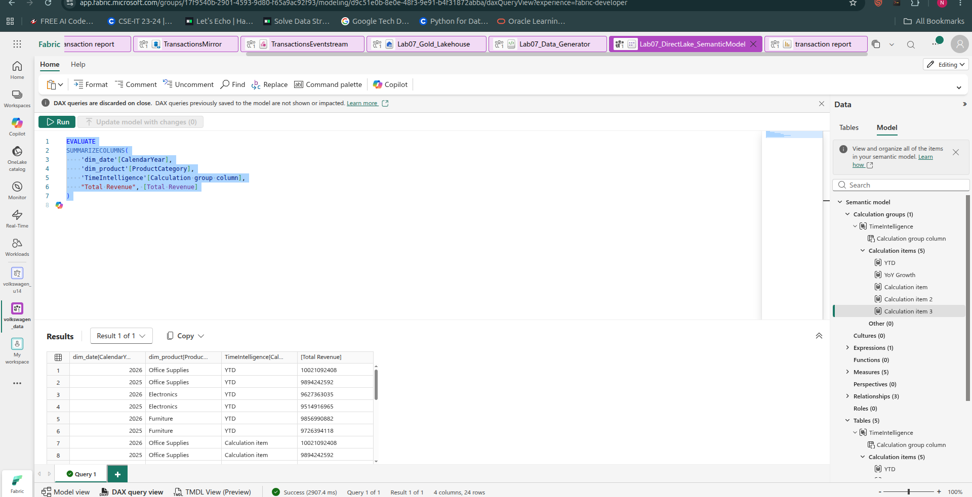

Step 14.5 — Check governance state
Return to the semantic model's Model view/TMDL View and verify that your model still contains the governance configuration from Step 08.
Also remember that Fabric IQ was not exposed in your workspace, so don't claim that the Fabric IQ mappings were configured.c

STEP 14 — Fabric Web Validation Visual.:



